**DAILY REPORT**

**Student Name :SINDHU.N**

**Class and Sec : VI B**

**USN :4AL17CS094**

**DATE:10-08-2020**

|  |  |  |  |  |
| --- | --- | --- | --- | --- |
| **Online Test Details** | | | | |
| **Subject** | ------ | | | |
| **Semester** | VI -B | | **Duration** | ----------- |
| **% of marks** | | ---- | | |

|  |  |  |  |
| --- | --- | --- | --- |
| **Certification Course Details** | | | |
| **Course** | Cyber Security | | |
| **Certificate Provider** | Great Learning | **Duration** | 5.5hours |

**Snapshots of the daily class acitivities .**

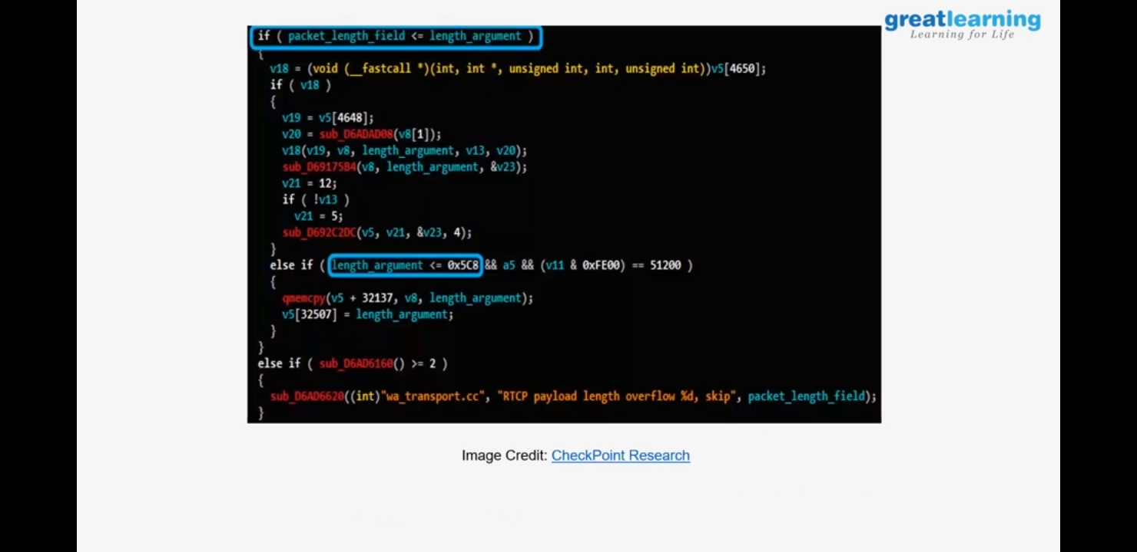



|  |  |
| --- | --- |
| **Coding Challenges** | |
| **Problem Statement:** 1.**Check whether a number has consecutive 0’s in the given base or not**.**** | |
| **Status:** Executed | |
| **Uploaded the report both in Github & Slack** | Yes |

**Snapshots of your response to challenge.**

1. ****Check whether a number has consecutive 0’s in the given base or not.****

def hasConsecutiveZeroes(N, K):

z = toK(N, K)

if (check(z)):

print("Yes")

else:

print("No")

def toK(N, K):

w = 1

s = 0

while (N != 0):

r = N % K

N = N//K

s = r * w + s

w* = 10

return s

def check(N):

fl = False

while (N != 0):

r = N % 10

N = N//10

if (fl == True and r == 0):

return False

if (r > 0):

fl = False

continue

fl = True

return True

N, K = 15, 8

hasConsecutiveZeroes(N, K)

**OUTPUT**

